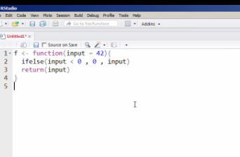

Don’t need a return

If instead, it would return input